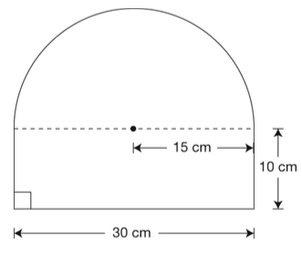
Knowledge and Understanding

- This sign is made up of a rectangle and a semicircle. Which of the following is closest to the area of the sign?
  - 347 cm²
  - 653 cm²
  - 1007 cm²
  - 1410 cm²

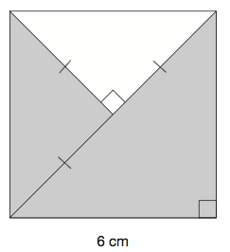
- What is the area of the shaded part of this square?
  - 36 cm²
  - 27 cm²
  - 18 cm²
  - 9 cm²

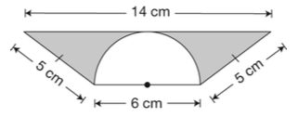
- This diagram is made of a trapezoid and a semicircle. Which is closest to the area of the shaded part of the diagram?
  - 2 cm²
  - 16 cm²
  - 21 cm²
  - 36 cm²

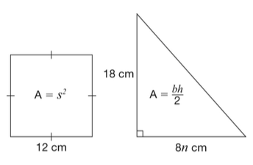
- This square and triangle have the same area. What is the value of n?
  - 1
  - 2
  - 8
  - 16

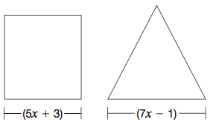
- This square and this equilateral triangle have the same perimeter. What is the value of x?
  - 2
  - 4
  - 9
  - 15

- Alison and Senna use 24 large square tiles to create a dance floor. They arrange the tiles to make a rectangular area with the smallest possible perimeter. Which arrangement creates an area with the smallest possible perimeter?
  - 1 row of 24 tiles
  - 2 rows of 12 tiles
  - 3 rows of 8 tiles
  - 4 rows of 6 tiles

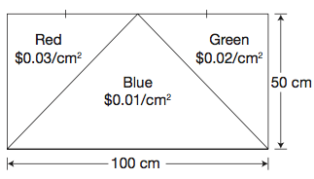
- Will and Dominyk are designing a rectangular flag with three coloured triangles. This picture shows the colours of the triangles and the cost of each colour of material. What is the total cost of the material?
  - $75.00
  - $87.50
  - $150.00
  - $175.00

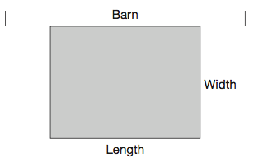
- Kierra and Sarah use fencing to create a rectangular horse enclosure. They use the side of the barn as one of the sides of the enclosure. They have 48 metres of fencing to use for the three sides of the rectangular enclosure. Which set of dimensions will use the entire 48 m of fencing?
  - Width is 8 m, length is 6 m
  - Width is 12 m, length is 12 m
  - Width is 24 m, length is 12 m
  - Width is 12 m, length is 24 m

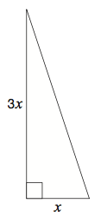
- Noah designs a garden in the shape of a right triangle as shown below. The total area of the garden is 96 m². Which is closest to the value of x in the diagram?
  - 6 m
  - 8 m
  - 32 m
  - 64 m

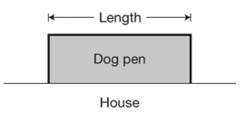
- Sean is helping Aiden build a rectangular dog pen along the side of his house. Aiden has 20 m of fencing for the 3 sides of the dog pen. What is the length of the dog pen with the maximum area?
  - 4 m
  - 5 m
  - 10 m
  - 12 m

- Hayden wants a rectangle with a perimeter of 100 cm and the largest possible area. What are the dimensions of the rectangle that satisfies his conditions?
  - 10 cm X 10 cm
  - 20 cm X 30 cm
  - 25 cm X 25 cm
  - 40 cm X 60 cm

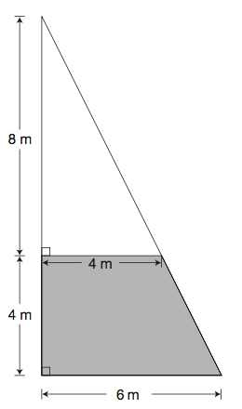

- The unshaded part of this sail is made with material that costs $32/m². The material for the shaded part of the sail costs $125/ m². Determine the total cost of the sail.
Application
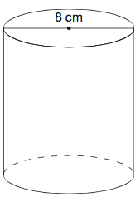
- This cylinder has a volume of 150 cm³. Which of the following is closest to the area of the lateral surface of the cylinder?
  - 38 cm²
  - 75 cm²
  - 150 cm²
  - 300 cm²

- A cylinder has a volume of 400π cm³ and a diameter of 20 cm. Which of the following is closest to the height of the cylinder?
  - 1 cm
  - 4 cm
  - 20 cm
  - 40 cm

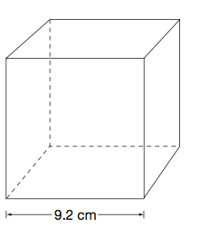

- A decoration is packed in a box shaped like a cube as shown. The decoration has a volume of 651 cm³. Approximately how much empty space remains in the box?
  - 128 cm³
  - 143 cm³
  - 623 cm³
  - 779 cm³

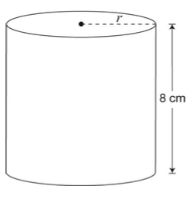
- The volume of this cylinder is 408 cm³. Which of the following is closet to the radius of the cylinder?
  - 4 cm
  - 8 cm
  - 14 cm
  - 16 cm

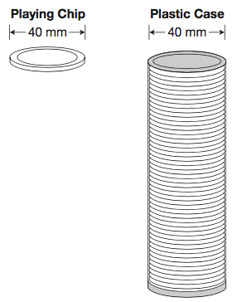
- The playing chips of a board game are stored in cylindrical plastic cases. The plastic cases have a volume of 25 120 mm³ and a diameter of 40 mm. Which of the following is closest to the height of one playing chip if 50 playing chips can fit tightly into the plastic case as shown above?
  - 0.1 mm
  - 0.4 mm
  - 1.3 mm
  - 2.5 mm

- A cylinder has a radius of 3 cm and a height of 10 cm. Which of the following is closest to the volume of the cylinder?
  - 188 cm³
  - 283 cm³
  - 888 cm³
  - 8882 cm³

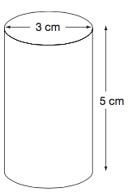
- This water container needs to be filled. Which of the following represents the volume, in cm³, of water that would fill the container completely?
  - V = π(3²)(5)
  - V = π(1.5)(5)
  - V = π(2 X 3)(5)
  - V = π(1.5)²(5)

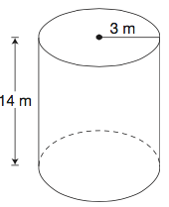
- Which of the following is closest to the volume of this cylinder?
  - 126 m³
  - 132 m³
  - 264 m³
  - 396 m³

- This square-based prism has a height of 3 cm. Which table represents the relationship between the side length and the volume of the prism?
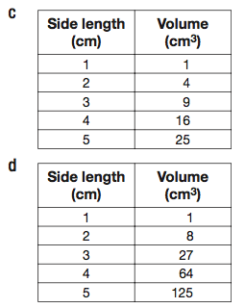
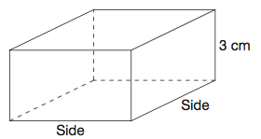
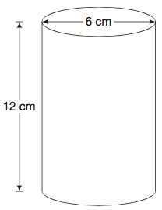
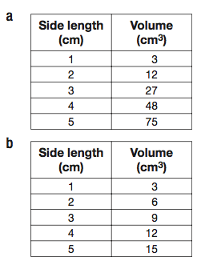

- A wax candle is in the shape of a cylinder. Which is closest to the total amount of wax to make the candle?
  - 226 cm³
  - 339 cm³
  - 452 cm³
  - 1357 cm³

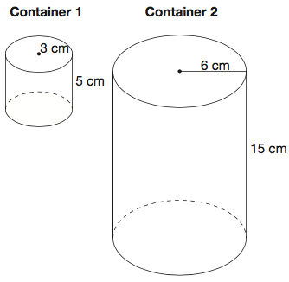
- Here are two different cylindrical milk containers. When the containers are full of milk, what is the ratio of the amount in Container 1 to the amount in Container 2?

Thinking and Investigation

- A cylindrical sports bag is 40 cm long. Its surface area (in cm²) is numerically equal to its volume (in cm³). How tall is the bag? Round your answer to 2 places after the decimal.
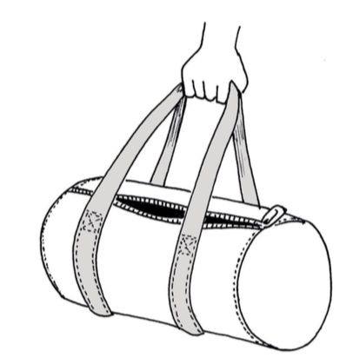

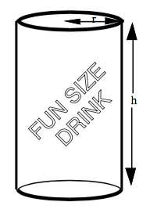
Communication (Long-Answer)

- You are in charge of creating a new soft drink can. This can needs to hold 200 cm³ of liquid.

  - Here are two suggestions for the radius of the cylindrical can. What would the height and surface area of the can be in each case? Are the dimensions of the cans suitable? Explain your answer.
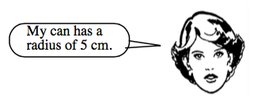
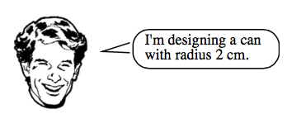

  - In order to save money, the can needs to be designed so that it requires the smallest quantity of aluminum. Find the radius and height of the can that does this, to two decimal places.

 | Evaluation Rubric
 | Level 4 |  | Level 3 |  | Level 2 |  | Level 1
K/U | 8m36 Solve problems involving the estimation and calculation of the circumference and the area of a circle
K/U | - Identifies all correct answers  - Shows all work  - Justifies each step using surface area formulas  - Uses descriptive labels for each section of work |  | - Identifies most correct answers  - Shows most work  - Justifies most steps using surface area formulas  - Uses descriptive labels for most sections of work |  | - Identifies some correct answers  - Shows some work  - Justifies some steps using surface area formulas  - Uses labels for some sections of work, not all labels are descriptive |  | - Identifies few correct answers  - Shows few or no work  - Justifies few or no steps using surface area formulas  - Uses few or no labels, or labels aren’t descriptive
App. | 8m39 Solve problems involving the surface area and the volume of cylinders
App. | - Identifies all correct answers  - Shows all work  - Justifies each step using surface volume formulas  - Uses descriptive labels for each section of work |  | - Identifies most correct answers  - Shows most work  - Justifies most steps using surface volume formulas  - Uses descriptive labels for most sections of work |  | - Identifies some correct answers  - Shows some work  - Justifies some steps using surface volume formulas  - Uses labels for some sections of work, not all labels are descriptive |  | - Identifies few correct answers  - Shows few or no work  - Justifies few or no steps using surface volume formulas  - Uses few or no labels, or labels aren’t descriptive
T/I | 8m39 Solve problems involving the surface area and the volume of cylinders
T/I | - Identifies all correct answers  - Shows all work  - Justifies each step using surface area or volume formulas  - Uses descriptive labels for each section of work |  | - Identifies most correct answers  - Shows most work  - Justifies most steps using surface area or volume formulas  - Uses descriptive labels for most sections of work |  | - Identifies some correct answers  - Shows some work  - Justifies some steps using surface area or volume formulas  - Uses labels for some sections of work, not all labels are descriptive |  | - Identifies few correct answers  - Shows few or no work  - Justifies few or no steps using surface area or volume formulas  - Uses few or no labels, or labels aren’t descriptive
Comm. | 8m39 Solve problems involving the surface area and the volume of cylinders
Comm. | - Identifies all correct answers  - Shows all work  - Thoroughly explains thinking, clearly and logically  - Backs up reasoning with mathematical arguments  - Uses descriptive labels for each section of work |  | - Identifies most correct answers  - Shows most work  - Usually explains thinking, clearly and logically  - Usually backs up reasoning with mathematical arguments  - Uses descriptive labels for most sections of work |  | - Identifies some correct answers  - Shows some work  - Sometimes explains thinking, more or less clearly/logically  - Sometimes backs up reasoning with mathematical arguments  - Uses labels for some sections of work, not all labels are descriptive |  | - Identifies few correct answers  - Shows few or no work  - Rarely or never explains thinking, or not clear/logical  - Rarely or never backs up reasoning with mathematical arguments  - Uses few or no labels, or labels aren’t descriptive
 | Overall Achievement Level
 | Level | Range | Level | Range | Level | Range | Level | Range
 | 4+ | 95 - 100 % | 3+ | 77 – 79 % | 2+ | 67 - 69 % | 1+ | 57 - 59 %
 | 4 | 87 – 94 % | 3 | 73 – 76 % | 2 | 63 – 66 % | 1 | 53 – 56 %
 | 4- | 80 – 86 % | 3- | 70 – 72 % | 2- | 60 – 62 % | 1- | 50 – 52 %

